Week – 7
Team Details:
Guggilam Leela Naga Sai Sri Saketh – AP23110010510
Seshagiri BharadwajSai – AP23110010367
Annam Surya Teja – AP2310010525
Hrushikesh Bhaskar Gopale – AP23110010129
Insights Report
- The Random Forest Classifier provided the best predictive results for detecting Autism in adults, with:
  - Accuracy: 95%
  - AUC Score: 0.9972
- High precision and recall scores for both autistic and non-autistic classes, demonstrating robust classification capabilities.
Feature Analysis:
- Based on the feature importance graph, the top features contributing to the model's decision-making were:
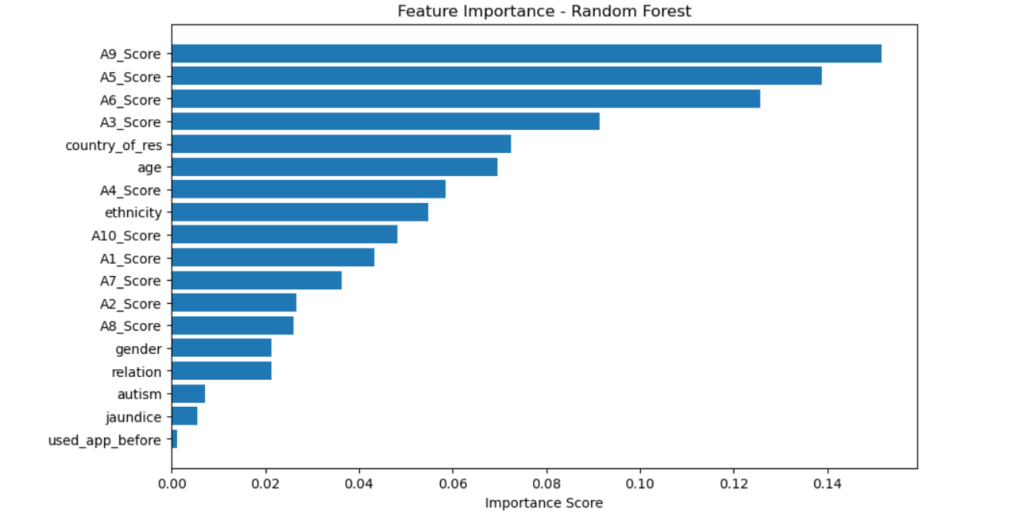
- A9_Score, A5_Score, and A6_Score — indicating specific behavioral patterns are highly predictive.
- A3_Score, country_of_res, and age also significantly influenced predictions.
- Lesser but still relevant features included ethnicity, gender, relation, and autism (which are related to the family history).
- Least impactful features included used_app_before and jaundice
Interpretability & Insights
- The feature importance results provide interpretability to the model, giving psychological researchers and practitioners clear insight into which screening questions (especially A5, A6, A9) are most indicative of potential autism in adults.
- The model also suggests demographic factors like age and country of residence play a secondary but notable role.
- The final trained model is integrated into a web-based screening application developed using HTML, CSS and Flask. Where the individual enters the screening scores and demographical data it will predict that the adult individual has autism or not.

